SIMATS ENGINEERING

Atsayaa.R
(192412024)

Experiment 17

ITA0606
Machine Learning

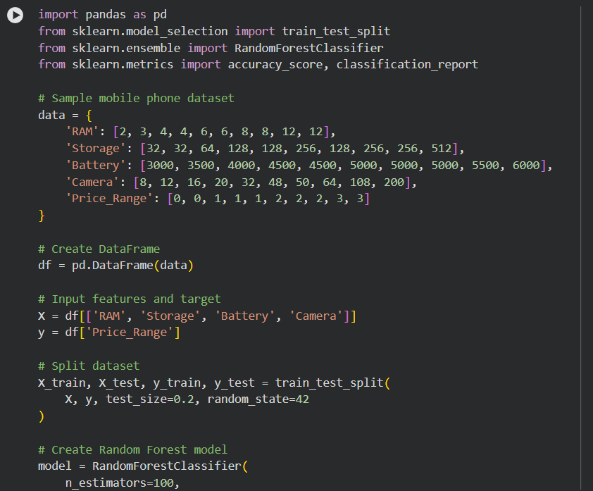
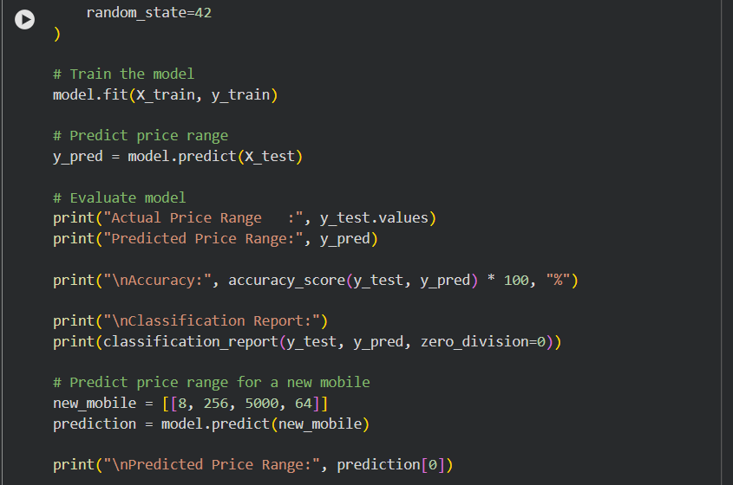

OUTPUT
